Marvellous Balogun

Joel Jose

Edgar Perez

Nicholas Tran

Lipika Arya

***Test Scenarios***

User selects the user type “employee”, then types in username and password. User presses the clock-in button, the user then clocks out and logs out. User quits.

User selects the user type “employer”, then types in username and password. User chooses to look at an employee’s work hours. User quits.

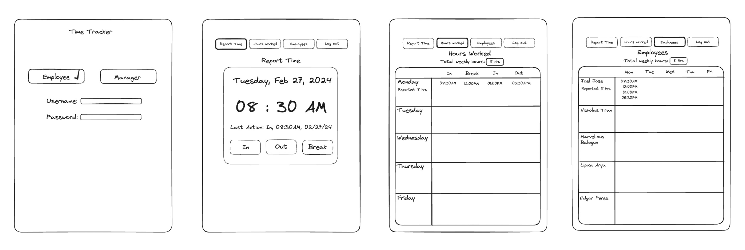

***Wireframe***